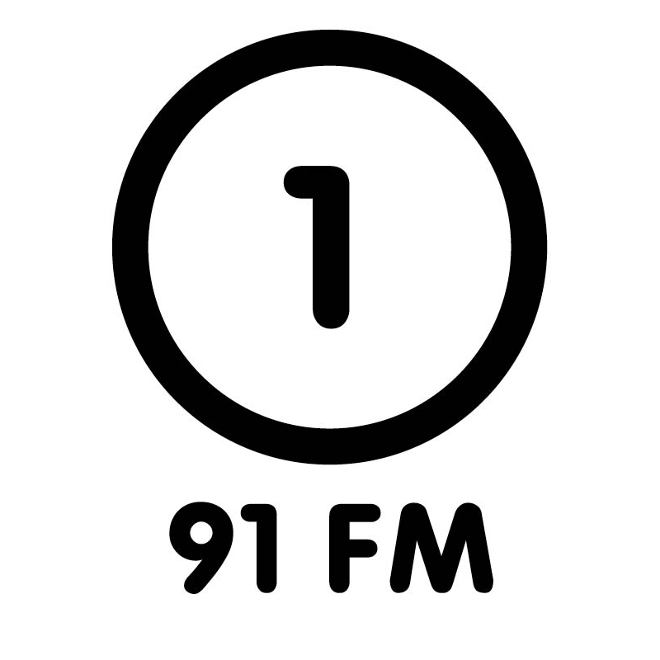
RADIO ONE 91FM
Volunteer Application Form
~ 2024 ~

There are many ways you can become involved in your favourite radio station! From reading the news, hosting a show, or just lending a helping hand and being rad. Fill out the application form and whip it back through to us at r1@r1.co.nz, or drop it back into the Radio One office. We would love to hear from you!

Date of application:

Name:

Preferred Pronouns:

Address:

Contact Number:

Email:

Age:

Are you a student? What are you studying?

Why would you like to volunteer at Radio One? What are your goals in being involved with the station?

List any relevant experience and/or qualifications you have in broadcasting, music, or journalism:

What radio station(s) and podcast(s) do you listen to?

How many hours a week can you be involved? Which days, and what times?
What areas of Radio One are you interested in working in?
(Please tick where appropriate)

On Air:
- Announcing (DJing / Hosting Radio)
- Contributing to features (Interviewing / Reviewing / Editorial)
- News (Compiling / Reading Bulletins)

(NB - If you are applying for an on-air position it is essential that you complete and submit a voice recording; see the next page.)

Production & Copywriting:
- Scriptwriting (advertisements, promos, sound bytes)
- Voice talent (advertisements, promos, sound bytes)
- Making backing music for advertisements / promos

Promotion:
- Art (drawing / illustrating, designing posters / promo material)
- Street team (postering / giving away things to public / surveying public)
- Helping out at events

Tech/Communications:
- Website / podcast maintenance
- Music database maintenance

Archiving:
- Organising and General Office duties
- Labelling and Cataloguing music albums

What were the last few concerts/live music shows/gigs that you attended?

What were the last few items of music you paid to purchase / download?

Please circle your musical interests:

Pop
Indie Rock
New Wave
House
Electronic
Electro
Techno
Disco
Industrial
Experimental
Drum'n'Bass
Hip Hop
Trap
Funk
Soul
Blues
Dub
Dancehall
Reggae
Dubstep
Punk
Postpunk
Hardcore / Metal
Psych
Prog
Surf Rock
Ska / Rocksteady
Jazz
Country
Folk
Dad Rock
Yacht Rock
Classical
Shoegaze
Hyperpop
Other?

Are you particularly clued-up on any of the above areas? If so, which ones?

Are you interested in helping with specialist (talk-based / genre) shows if the opportunity comes up? If so, which ones?

As an example of the range and depth of your musical knowledge, please list 30 songs (and their performers) that you would consider appropriate for airplay on Radio One. We operate with a quota of 30% NZ music at a minimum, please follow this on your tracklist.

1. 16.
2. 17.
3. 18.
4. 19.
5. 20.
6. 21.
7. 22.
8. 23.
9. 24.
10. 25.
11. 26.
12. 27.
13. 28.
14. 29.
15. 30.

